--1. Write a query to fetch the details of the books written by author whose name ends with er.

select author from books where author like '%er'

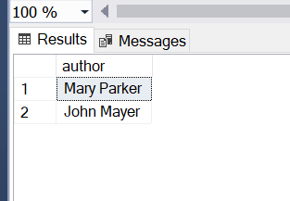

--2.Display the Title ,Author and ReviewerName for all the books from the above table

select title,Author ,Reviewer_Name from books join reviews on books.id=reviews.id

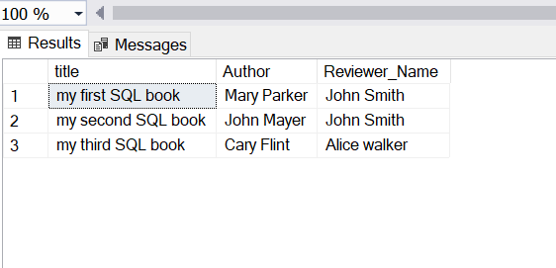

--3.Display the reviewer name who reviewed more than one book.

select reviewer_name from reviews group by reviewer_name having COUNT(*) > 1

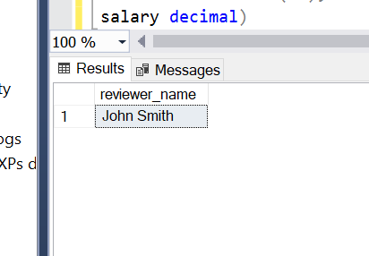

--4.Display the Name for the customer from above customer table who live in same address which has character o anywhere in address

select * from customerr where cusaddress like '%o%'

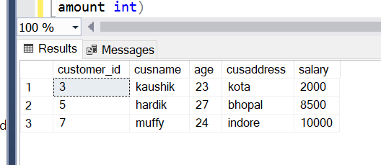

--5.Write a query to display the Date,Total no of customer placed order on same Date

select odate, count(DISTINCT customer_id) as total_customerr from orders group by odate

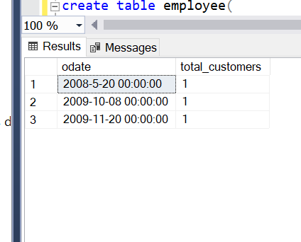

--6.Display the Names of the Employee in lower case, whose salary is null

select lower(ename) as 'lowercase name' from employee where salary is null

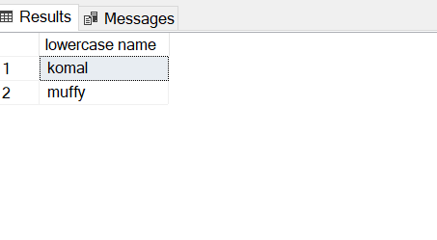

--7.Write a sql server query to display the Gender,Total no of male and female from the above relation

select gender, COUNT(*) AS total_count from studentdetails group by gender

